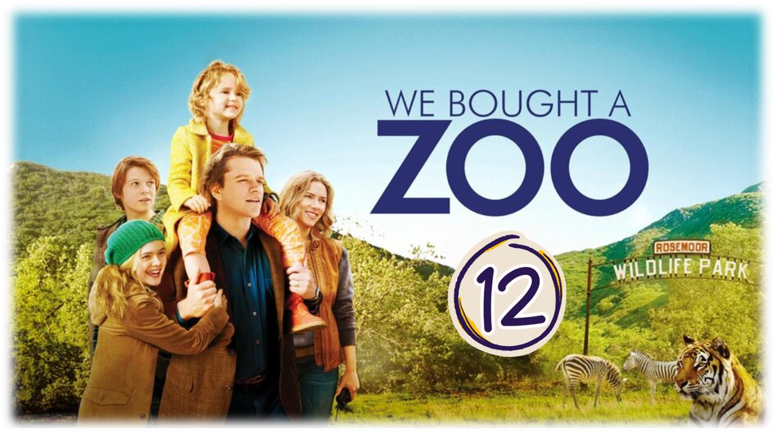

WORK ON SCENE

Scene summary: He also talks about his son but it was negative

In this scene we see Kelly with the children at home helping them preparing dinner. when Benjamin came home after feeling in a better mood, they talked together about Dylan and how he is always angry. Unfortunately, Dylan heard their conversation so he got angry and started screaming on his father . Benjamin tried to explained to him why he should stay in the zoo and help each other.

Scene Discussion & Analysis:
- Q01: Was Benjamin home? Where was he?
- No , he wasn’t . He was going out because he had a mood and needed to think , to be alone , and to get over
- Q02: What occupies his mind all the time?
- His mind is occupied by his late wife . He couldn’t keep going without her and missed her a lot .
- Q03: He thought he would get over it if he changes home ... was he able to?
Why?
Benjamin couldn’t get over his wife because he loved her . Everything reminds him of her because she lives in his mind and heart .
- Q04: Did that affect his relationship with his children? Why –in your opinion-? Explain and analyze!!
- The death of Catherine affected the relationship between Benjamin and his children especially with Dylan. Both of them are suffering to cope with the loss of her. Dylan misses his mom and can’t find someone who understands him. As for Benjamin he can’t figure it out as he was absent in the life of his children and his wife before . He found it hard to take all the responsibility . He didn’t give himself time to accept the reality that he is alone .
- Q05: Why was Dylan mad at his father?
- Dylan was mad at Benjamin because he talks negatively about him to Kelly.
- Q06: Do you think he had the right to act like that toward his father?
(explain your opinion)
Dylan doesn’t have the right to talk to his father in that aggressive way . He is behaving so because he is a sensitive teenager who is suffering after the death of his mom . He thinks that his father hates him . He finds hard to understand that he is doing the best he can for him and his sister .
- Q07: Do you agree with the father’s reaction? If not, what would you do if you were in his place?
Although the reaction of Benjamin is over but it is understandable. He is going through a lot. He is making lots of mistakes at the end of the day he is just a human being . What he told Kelly wasn’t nice towards his son . Dylan has the right to be mad at him and Benjamin felt maybe embarrassed that is why he forced his son to listen to him by shouting. Benjamin could just avoid all of this drama and instead of talking to Kelly, he talks to his son. Since he did a mistake he could just apologize or postpone their discussion until both of them are calm.
- Q08: Do your research and explain the story behind “The Easter Bunny”.
Ester Bunny is a fictional character , Like Santa Claus , first created by Germans . When they celebrate Easter they put some eggs for children to collect . Egg in this religious context symbolizes new beginning .
Acquired Vocabulary (OPTIONAL):

► To get over (something or someone):
  - Example in a sentence:
“ I got over my illness”
► To drive (someone) nuts: to push his bottons
  - Example in a sentence:
“ His jokes are driving me nuts “
Irregular Verbs:

Infinitive | Past simple | Past participle
To think | Thought | Thought
To bet | Bet | Bet
To drive | Drove | Driven

ADDITIONAL EXERCISE (OPTIONAL)
Task: Transcribe sentences from the scene.
► Transcribe Sentence 01
The air , the way it smelled in May and August , because those months were my favorite bushes grew flowers all over our neighborhood . They’re all triggers man . and it get better for a while …. I mean
► Transcribe Sentence 02
What I’ve figured out is that when you love somebody that much , that hard , that long you can never get away from them no matter where you go and that only comes once in a lifetime . Just can’t handle on it . I cannot let go .
► Transcribe Sentence 03
“ Yes , I can force a dream on you
- Why are you yelling ?
- Because it’s a good dream and it has got cool animals and some pretty great people , too . and because I’m your father , and I’m the only one you’ve got in the line of people in this world who really care about you , ends her “

